**Midterm Exam Review**

Midterm Consists of the following,

• True or False, give your answer why it is true or false

• Multiple choice questions

• Brief answers

• Able to write a Pseudo code for the given problems.

• Able to write Recursive Algorithms.

• Able to trace manually the working principles learned.

**A. Asymptotic Analysis**

1. Big-O: f(n) is O(g(n)) if f(n) is **asymptotically less than or equal** to g(n)

Given functions ***f***(***n***) and ***g***(***n***), we say that ***f***(***n***)is ***O***(***g***(***n***)). If f(n) *grows no faster* than g(n), we say f(n) is O(g(n))

(“big-oh”). We also say that g(n) is an ***asymptotic upper bound*** on f(n). We can use the big-Oh notation to rank functionsaccording to their growth rate.

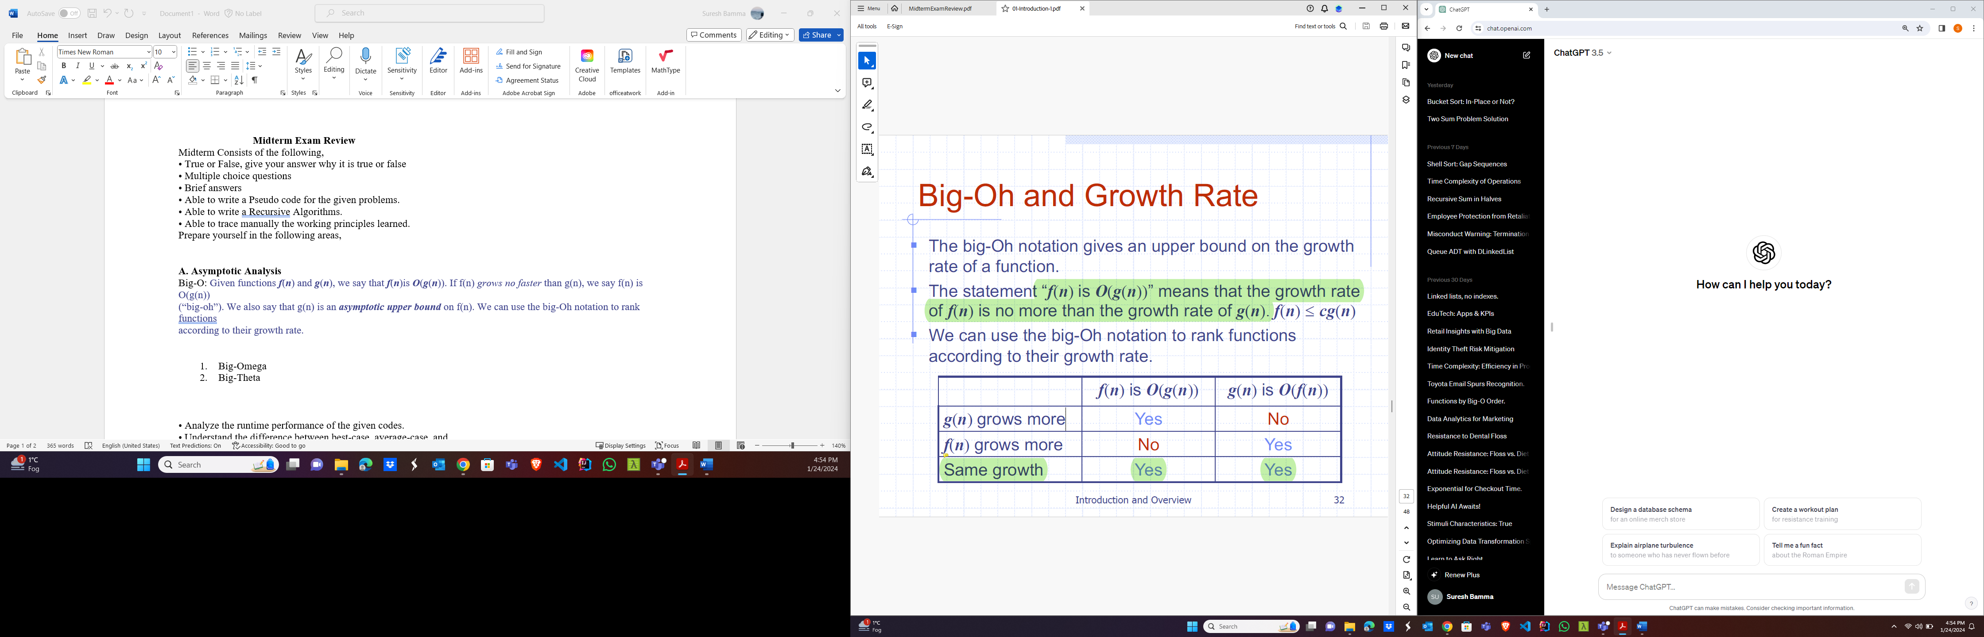

***Standard complexity classes***



1. Big-Omega: f(n) is omega(g(n)) if f(n) is **asymptotically greater than or equal** to g(n).
2. Big-Theta: f(n) is theta(g(n)) if f(n) is **asymptotically equal** to g(n).

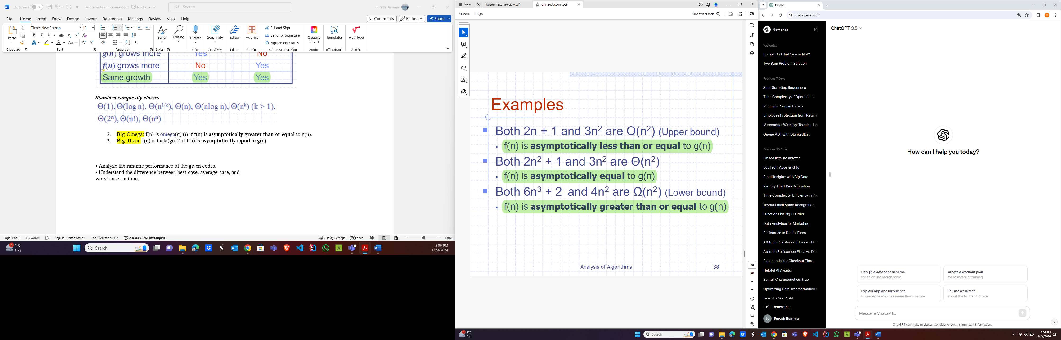

• Analyze the runtime performance of the given codes.

1. **O(1) constant**

i = 0;

while(i<5);

console.log(i)

i++;

1. **O(logn)** 🡺 **binary search (either increment multiply or divide by constant number at all the time)**

for(int j = 0; j < n; j = j *6)} //o(log n)

1. **O(n) linear(increment byconstant number eg. 1 until n)**

**Example:1**

int [] array = {2, 3, 5, 6, 8, 10, 13, 56}

public void calSum(int [] array){

int sum = 0;

for(int i = 0; i<n; i++){ // O(n)🡺 linear

sum+=i}

sout(“The sum of the given array is ” + sum}

**Example:2**

let i = 0;

while (i < n) {

console.log(i);

i++;

}

1. **O(n log n) (heap and merge sort)**

for(int i = 0; i < n; i++) { //o(n)🡺 **increment by 1 until n**

for(int j = 0; j < n; j = j *6)} //o(log n)🡺 increment multiple by 6 each time so size getting less.

🡺 O(n* log n) = O(n log n)

1. **O(n^2)**

public static example3(arr: number[]): number {

const n: number = arr.length;

let total: number = 0;

for (let j = 0; j < n; j++) {

// Loop from 0 to n-1

for (let k = 0; k <= j; k++) {

// Loop from 0 to j

total += arr[j];

}}

return total;}

1. **O(2^n) 🡺 generating subset.**

• **Understand the difference between best-case, average-case, and**

**worst-case runtime.**

**2. ADTs and data structures:**

• The difference between an ADT and a data structure.

1. Data structures: An efficient way of organizing data for storage and access by an algorithm is said to be data structures.
2. An ADT: it is an abstraction of a data structure which specifies the data stored, Operations on the data and error conditions associated with operations.

• **Stacks: properties, operations, runtimes, and when to use them.**

Insertions and deletions follow the last-in first-out (LIFO) scheme.

**Runtimes:**

Push Pop, Peek, isEmpty and Size operations have constant runtime since they only involves the top element of the stack.

**When to use stack:**

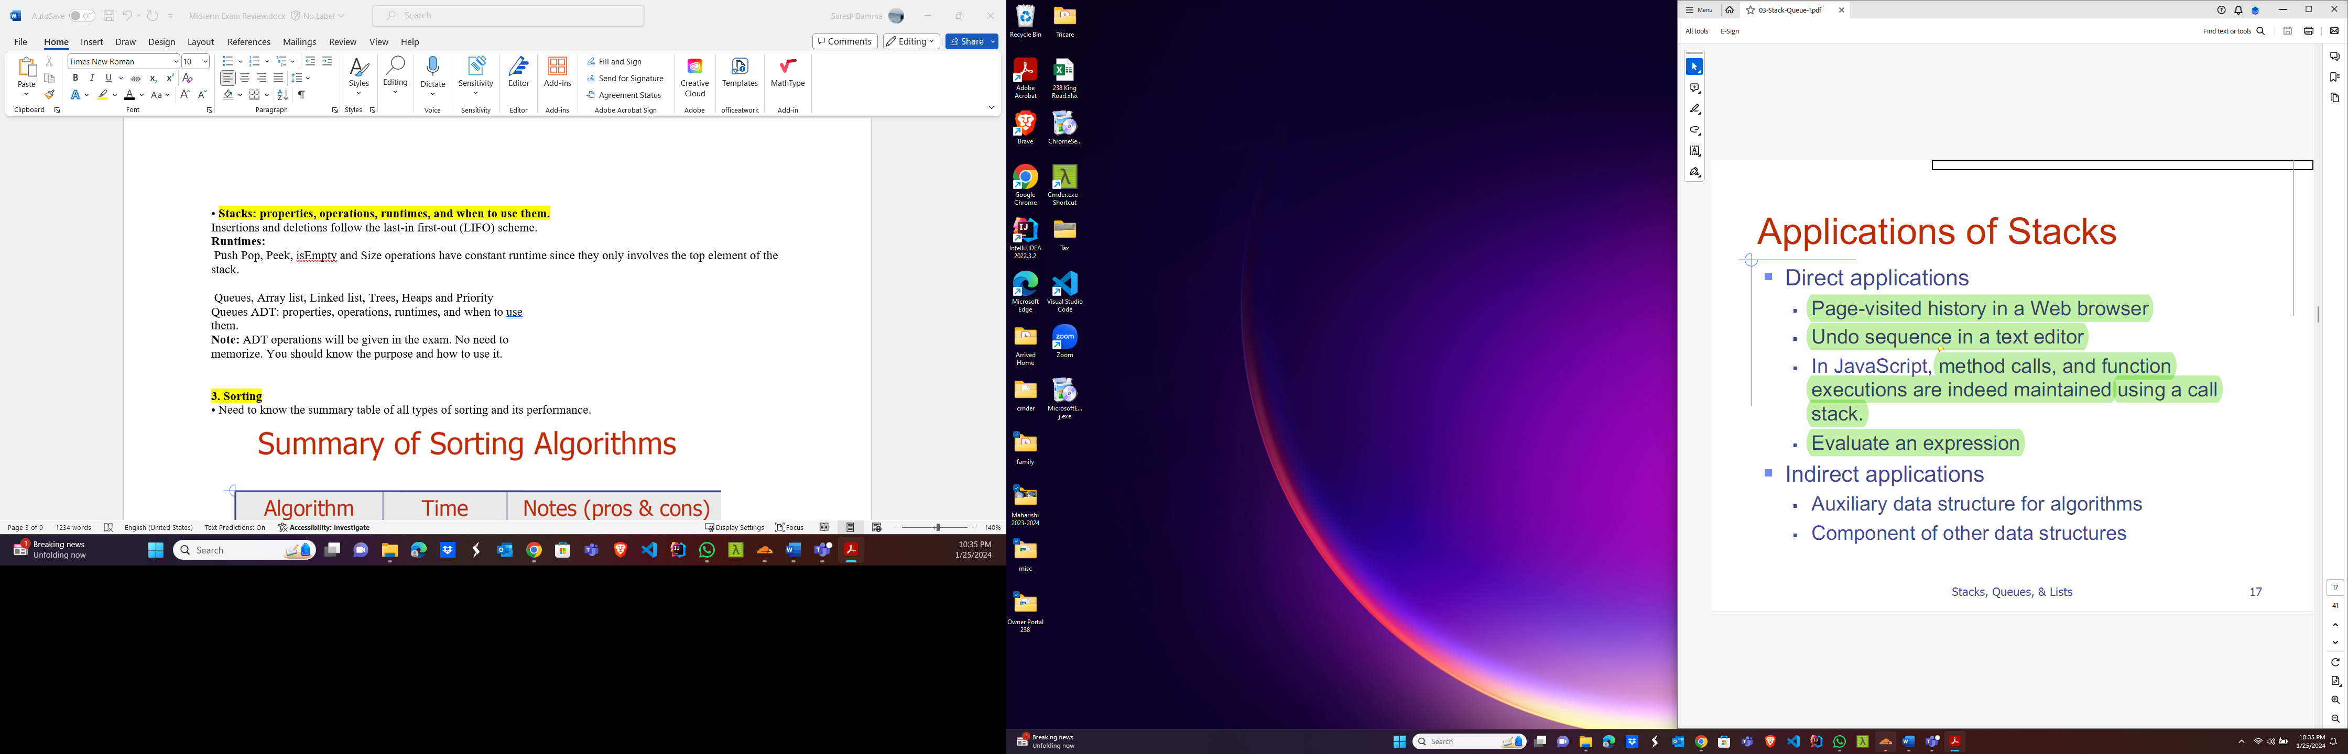

**Queues properties, operations, runtimes, and when to use them**

First In, First Out (FIFO) principle. In a queue, elements are added to the rear, and removal happens from the front.

**Runtimes:**

Enqueue, Dequeue, Front, isEmpty, Size: O(1) - constant time, as these operations only involve the front or rear of the queue.

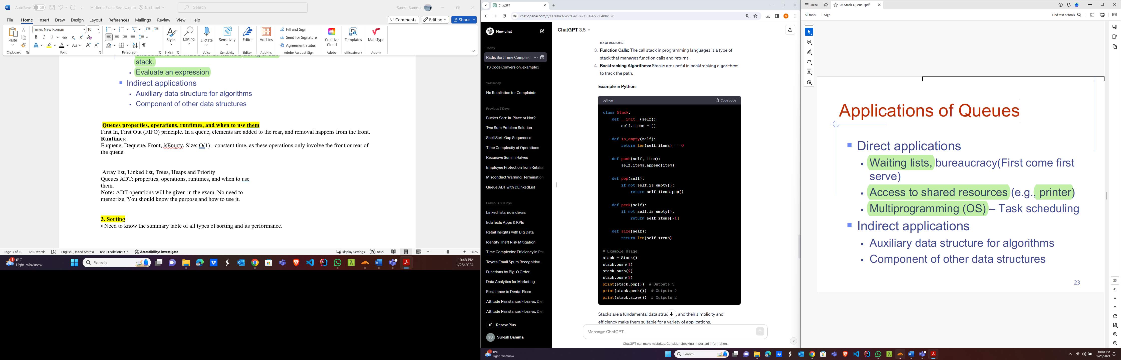

**Array list, Linked list, Trees, Heaps and PriorityQueues ADT: properties, operations, runtimes, and when to**

**use them.**

|  |  |  |  |  |
| --- | --- | --- | --- | --- |
| S N | Data Structure | Insert Item | Remove Min | Min Key Retrieve |
| 1 | Sorted Array | O(n) | O(1) | O(1) |
| 2 | Unsorted Array | O(1) | O(n) | O(n) |
| 3 | Sorted Linked List | O(n) | O(1) | O(1) |
| 4 | Unsorted Linked List | O(1) | O(n) | O(n) |
| 5 | Min Heap | O(log n) | O(log n) | O(l) |
|  |  |  |  |  |

**Note:** ADT operations will be given in the exam. No need to

memorize. You should know the purpose and how to use it.

**3. Sorting**

• Need to know the summary table of all types of sorting and its performance.

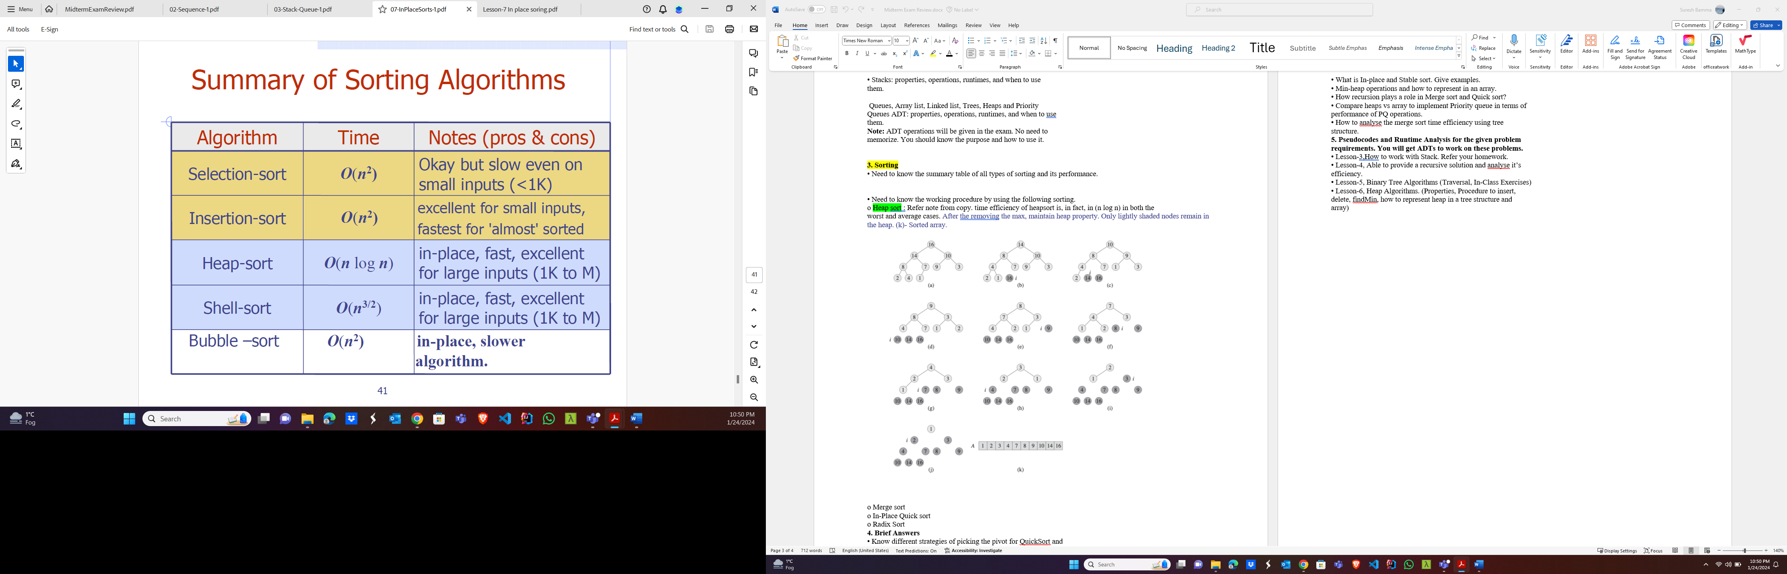

Note: shell sort running time is range of 1< r<2. O(n^r)

• Need to know the working procedure by using the following sorting.

o Heap sort : Refer note from copy. time efficiency of heapsort is, in fact, in (n log n) in both the

worst and average cases. After removing the max, maintain heap property. Only lightly shaded nodes remain in the heap. (k)- Sorted array.



o Merge sort: Refer example details in copy note.

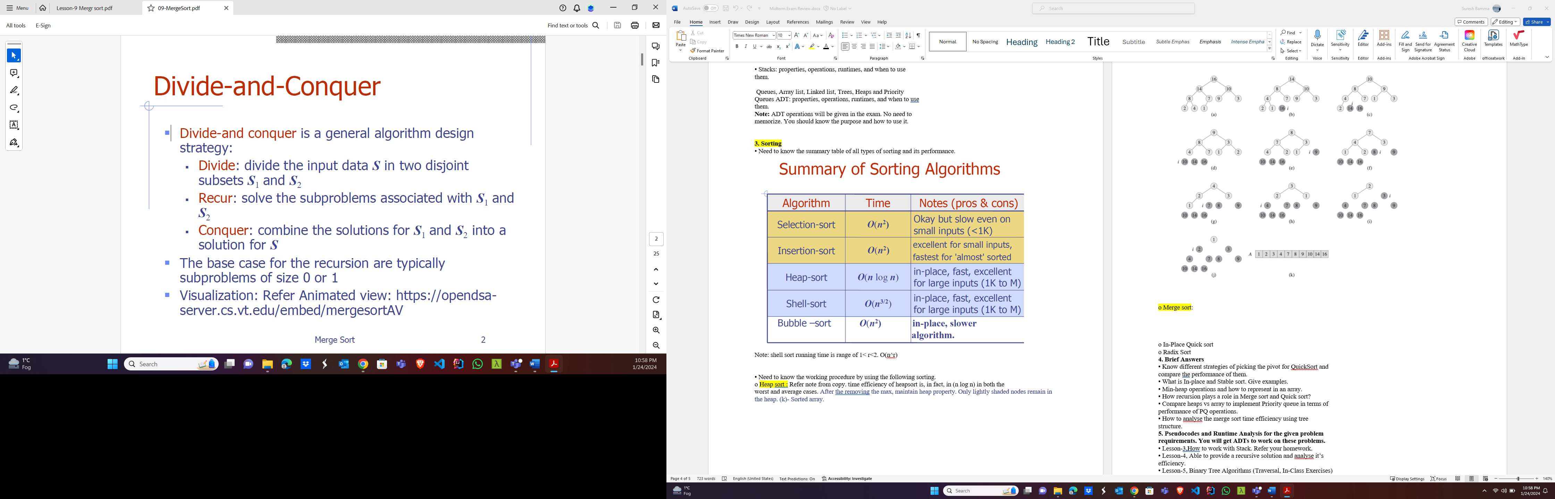

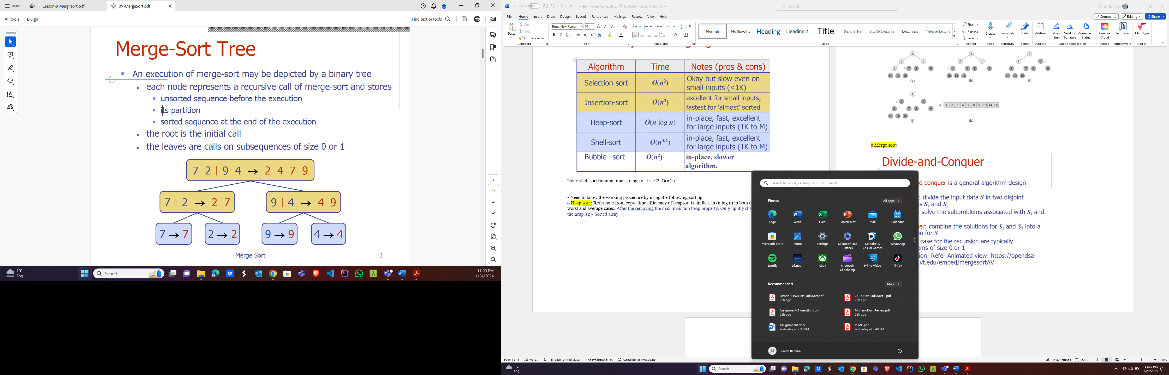

Thus, the total running time of merge-sort is ***O***(***n*** log ***n***). Diving O(log n) and merging O(n).

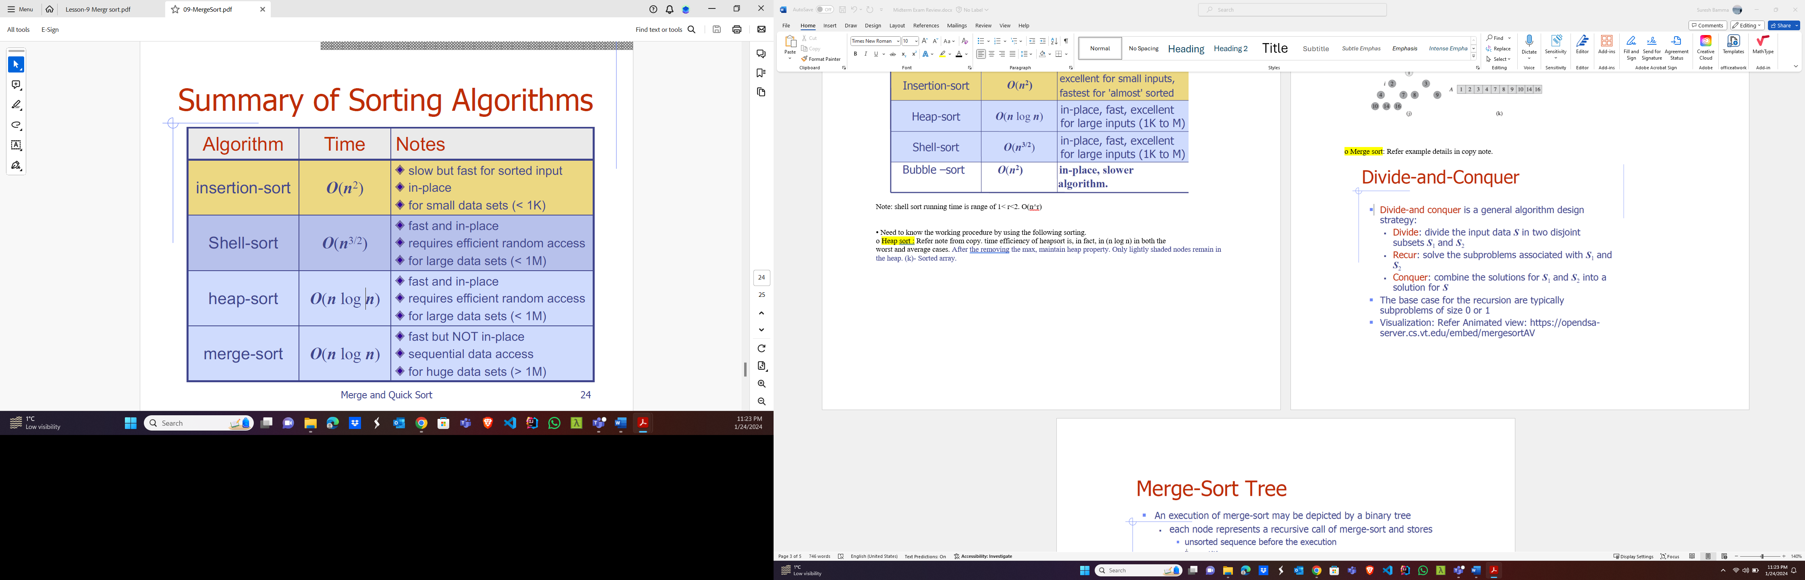

o In-Place Quick sort:

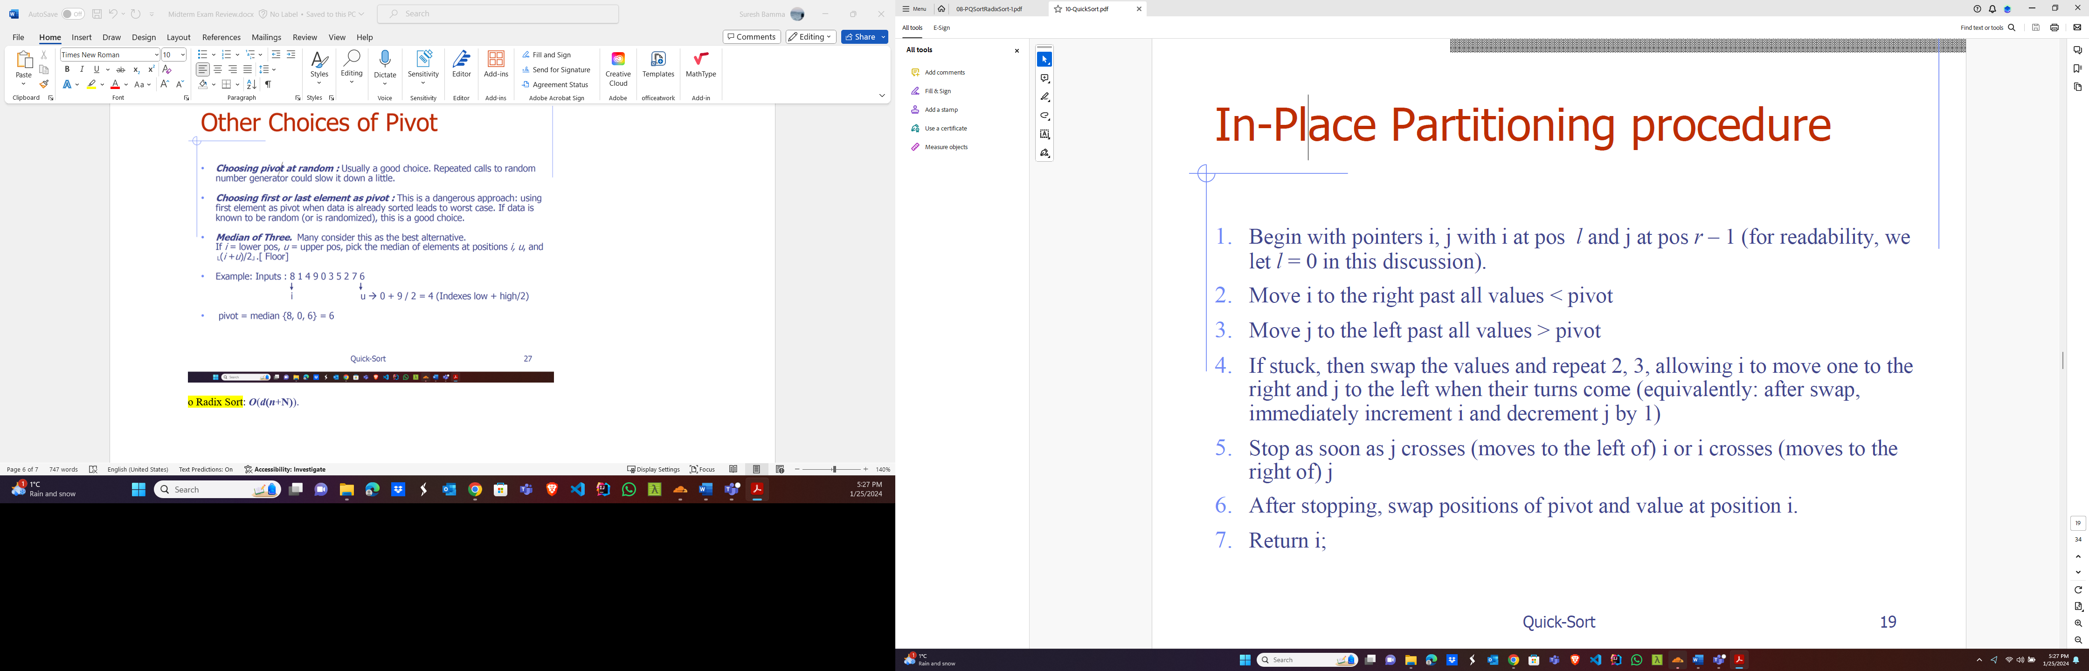

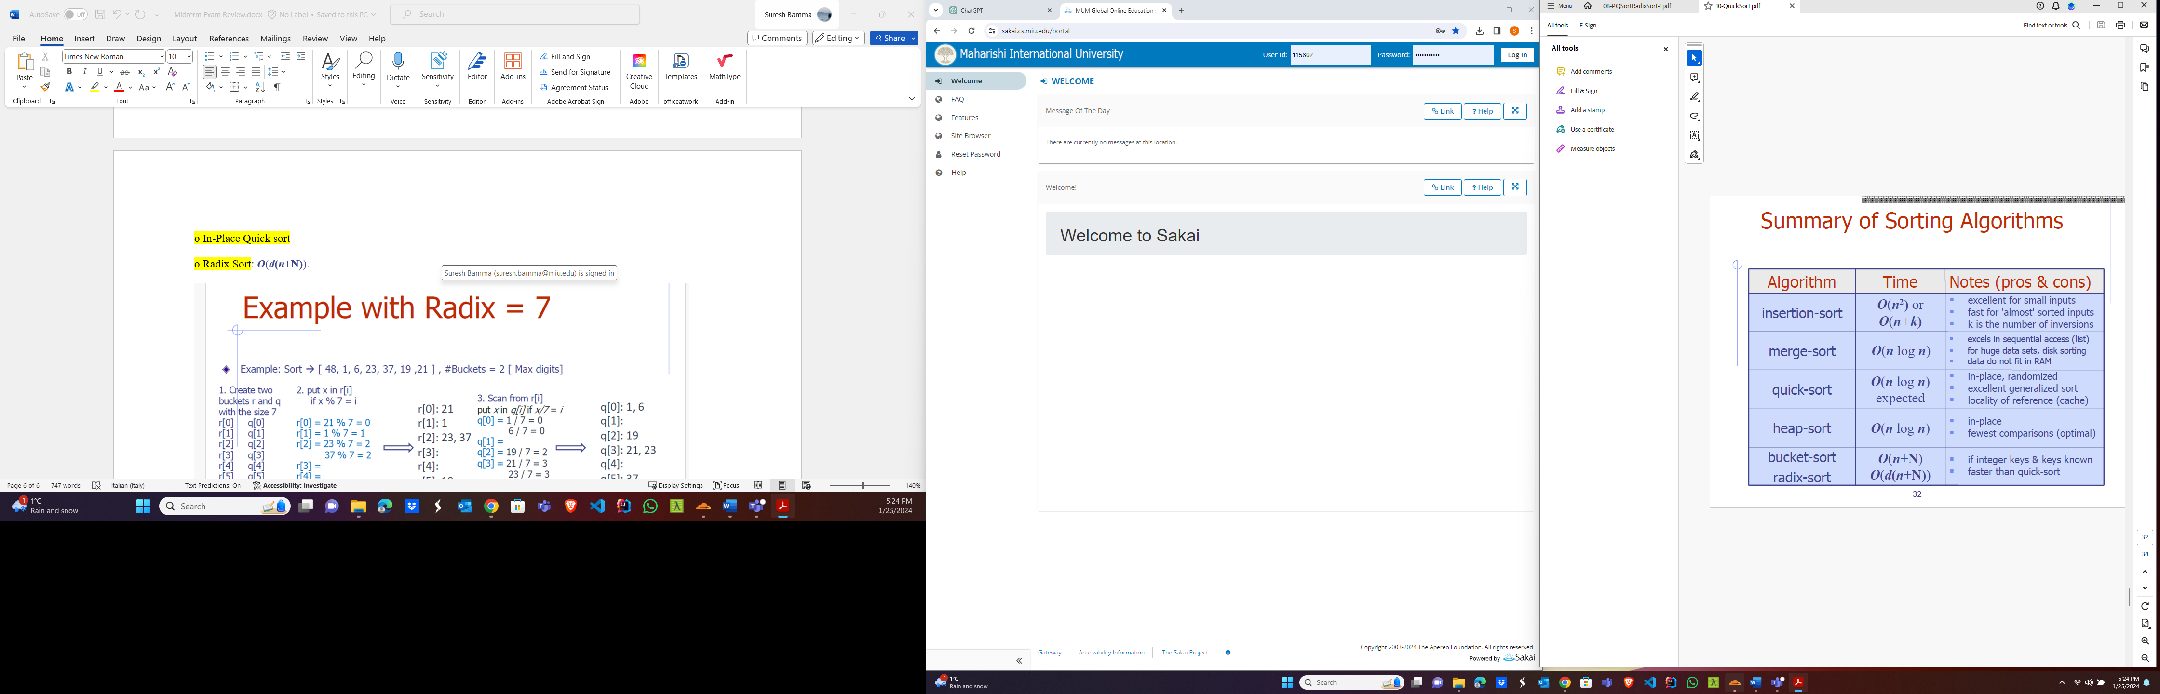

o Radix Sort: ***O***(***d*(*n*+N)**).

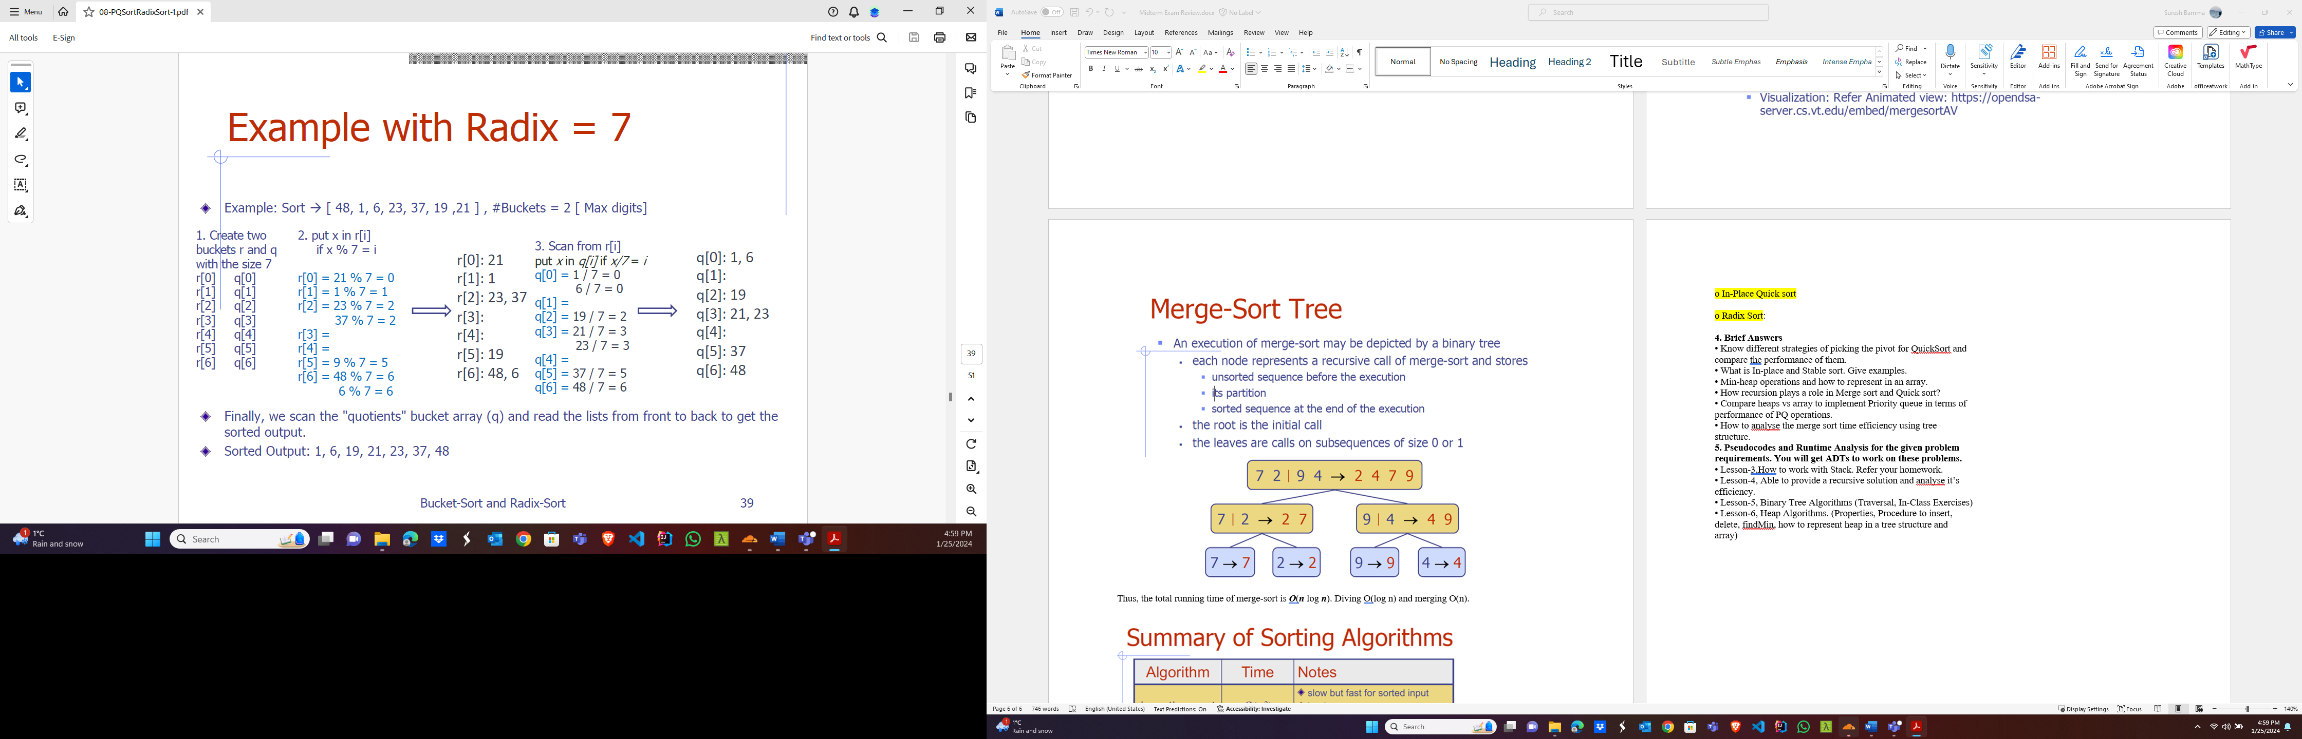

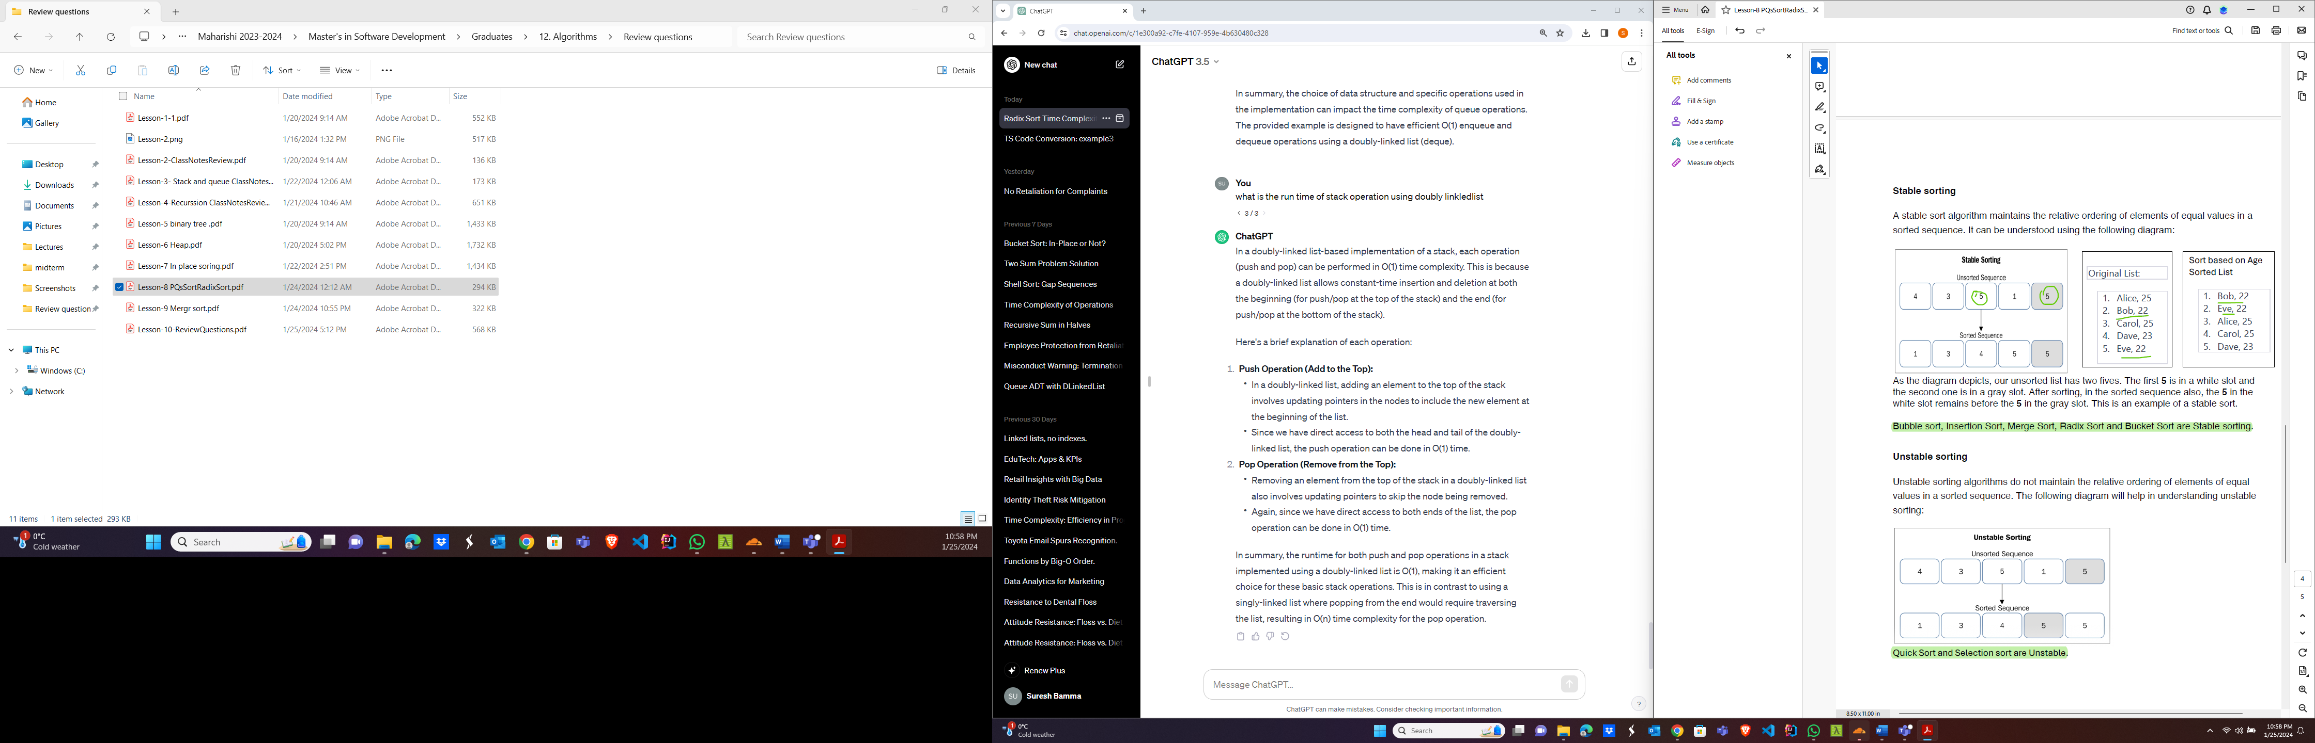

**4. Brief Answers**

• Know different strategies of picking the pivot for QuickSort and compare the performance of them.

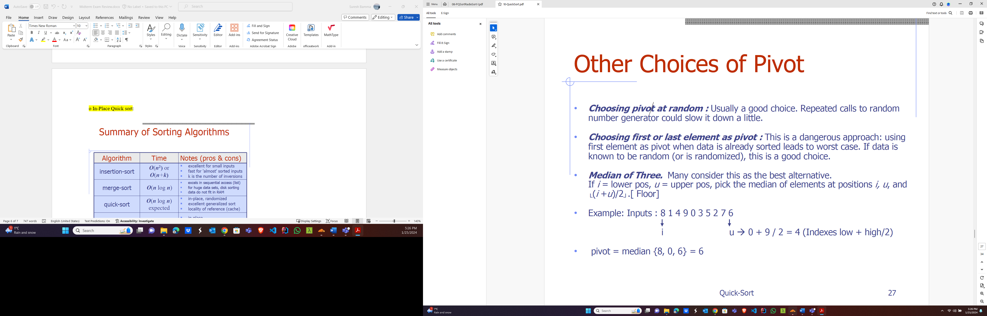

• What is In-place and Stable sort. Give examples.

**In-Place Sorting:**

An in-place sorting algorithm is one that doesn't require additional memory space, and it sorts the elements within the given array without using extra data structures. The sorting is performed directly on the input array, and the algorithm uses only a constant amount of extra memory for auxiliary variables. In-place sorting is efficient in terms of memory usage.

Example of an in-place sorting algorithm: Quicksort. Quicksort is an in-place sorting algorithm that follows the divide-and-conquer approach. It selects a pivot element and partitions the array into two sub-arrays such that elements less than the pivot are on the left, and elements greater than the pivot are on the right. The process is then applied recursively to the sub-arrays.

**Stable Sorting:**

A stable sorting algorithm maintains the relative order of equal elements in the sorted output as they were in the original input. In other words, if two elements are equal in the input, and one comes before the other, then after sorting, the one that came first should still appear before the other.

Example of a stable sorting algorithm: Merge Sort. Merge Sort is a stable, divide-and-conquer sorting algorithm. It divides the array into two halves, recursively sorts each half, and then merges the sorted halves. The merging step is designed to ensure stability by preserving the order of equal elements.

**• Min-heap operations and how to represent in an array.**

A min-heap is a binary heap data structure where the value of each node is less than or equal to the values of its children. The min-heap property ensures that the smallest element is at the root of the heap. New nodes must be added left to right at the lowest level,

The basic operations on a min-heap include:

1. Build heap
2. Insertion
3. Deletion

**Array Representation:**

Node objects are referenced by index:

Index 0 is empty and not used.

Root node is at index 1

Left child is at 2*its parent index

Right child is at 2*its parent index+1

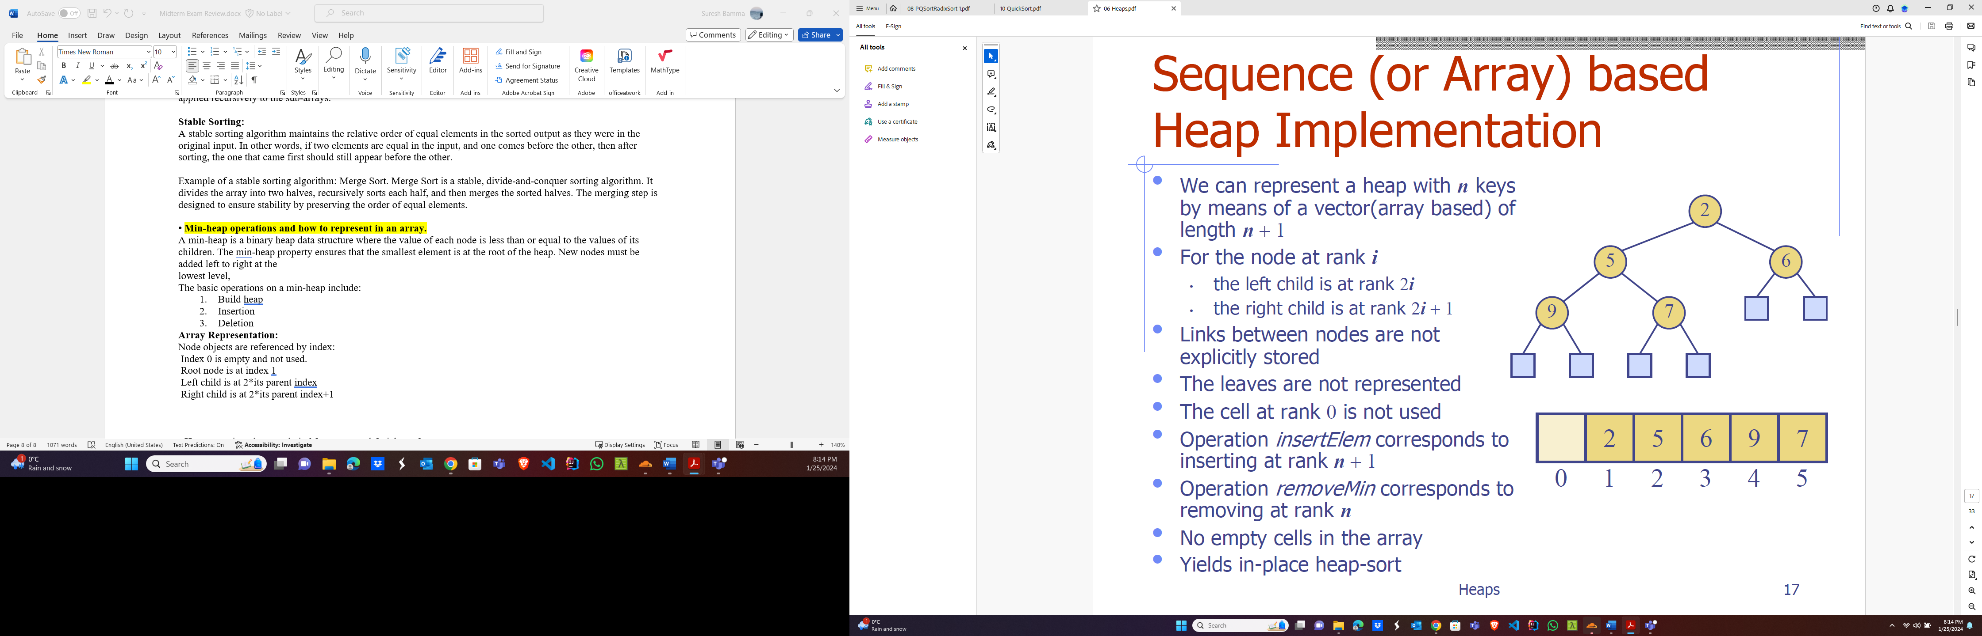

• **How recursion plays a role in Merge sort and Quick sort?**

Recursion plays a crucial role in both Merge Sort (Divide, conquer and merge) and Quicksort( partition, conquer and combine), as both of these sorting algorithms are based on the divide-and-conquer paradigm, which involves breaking down a problem into smaller sub-problems and solving them recursively.

**• Compare heaps vs array to implement Priority queue in terms of performance of PQ operations.**

|  |  |  |  |  |
| --- | --- | --- | --- | --- |
| S N | Data Structure | Insert Item | Remove Min | Min Key Retrieve |
| 1 | Sorted Array | O(n) | O(1) | O(1) |
| 2 | Unsorted Array | O(1) | O(n) | O(n) |
| 3 | Sorted Linked List | O(n) | O(1) | O(1) |
| 4 | Unsorted Linked List | O(1) | O(n) | O(n) |
| 5 | Min Heap | O(n log n) | O(n log n) | O(l) |

• **How to analyse the merge sort time efficiency using tree structure.**

The time complexity of Merge Sort is O(n log n), where n is the number of elements in the array. This analysis is based on the fact that the merge operation takes O(n) time, and there are O(log n) levels in the recursion tree.

**5. Pseudocodes and Runtime Analysis for the given problem requirements. You will get ADTs to work on these problems.**

• Lesson-3,How to work with Stack. Refer your homework.

Refer copy note.

• Lesson-4, Able to provide a recursive solution and analyse it’s efficiency.

Refer copy note.

• Lesson-5, Binary Tree Algorithms (Traversal, In-Class Exercises)

Binary Search Algorithm (recursive)

**Algorithm BinarySearchRec(S, k, low, high):**

**Input:** A sorted array S storing n items

**Output:** An element of S with value k between indices low & high.

if low > high then // Base Case, when k is not found

return **NO_SUCH_KEY**

else

mid ¬ floor((low + high)/2)

if k = S[mid] then // base case

return S[mid]

else if k < S[mid] then

return BinarySearchRec(S, k, low, mid-1) // Recursive call

else

return BinarySearchRec(S, k, mid + 1, high) // Recursive call

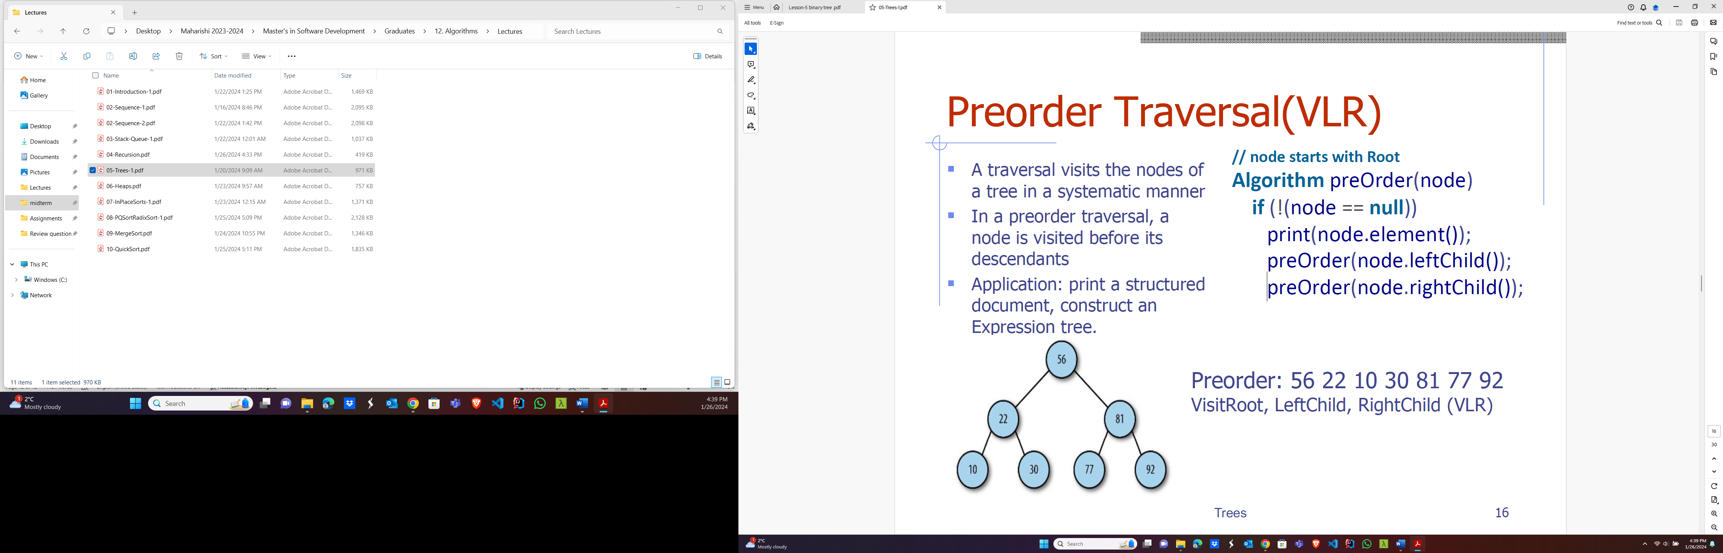

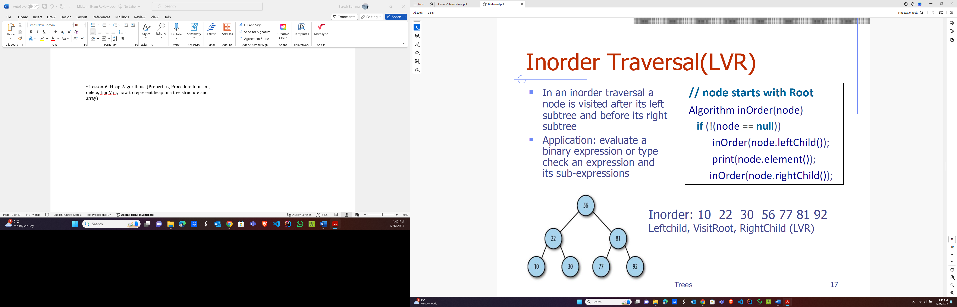

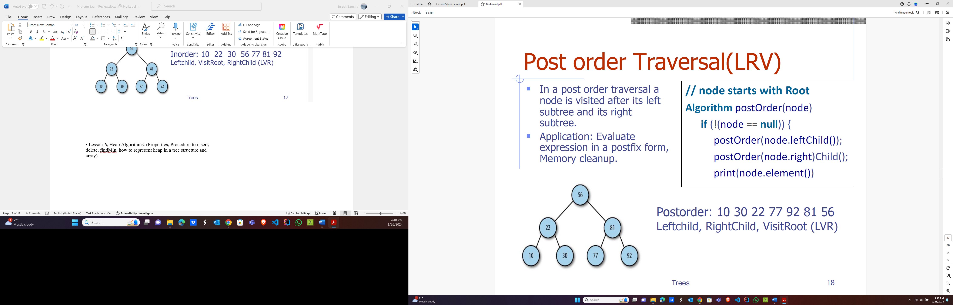

**• Lesson-6, Heap Algorithms.**

(Properties, Procedure to insert refer copy note , delete, findMin, how to represent heap in a tree structure and array)

Runtimes

Upheap, downheap, insert, delete 🡺 O(log n)